**Project Development phase**

**Project development_Delivery Of Sprint 2**

|  |  |
| --- | --- |
| Date | 22 October 2022 |
| Team ID | PNT2022TMIDT0411 |
| Project Name | IOT based gadget Child Safety monitoring and notification |
| Maximum Marks | 4 Marks |

INTRODUCTION

The challenge of discovering a drowning individual for experienced lifeguards remains daunting.

Underage and amateur swimmers are affected by the near-drowning incidents [1]. Victims are

confused, gasp for breath and try to avoid passage of water through their nostrils or mouth, which is

far the most devastating form of death. Lakes, rivers, beaches, and man-made water bodies are

common areas where drowning occurs. Domestic cases of the drowning of young infants are mostly

recorded during recreational activities such as swimming and diving into the deep. Investigations

confirmed that life-vest is the safest option to avert drowning; even if a swimmer floats on the cold-

water surface, the probability of him dying of hypothermia remains imminent [2].

World Health Organization (WHO) asserts that people under 25 years account for the average of

372,000 young people who die annually from drowning [3], which becomes one of the leading causes

of death among this age group. Also, the drowning incidents among children under age 15 accounts

for 135,585 deaths globally. In the African continent, drowning is rated twenty times higher than

1. other continents in the globe. In 2019, a drowning incident, which led to the Death of a graduate of the

Federal University of Technology, Owerri, encouraged the invention of an IoT-based safety device to

be worn by individuals before gaining access to the water. The device, in turn, alerts the lifeguards or

passersby immediately a swimmer encounters danger.

1.2 Problem Statement

There is a need to deploy an IoT - based device to monitor, discover, track and locate anyone in danger

of drowning in a water body and alert lifeguards to save them. The effective application of the IoT–

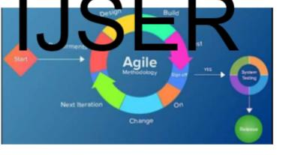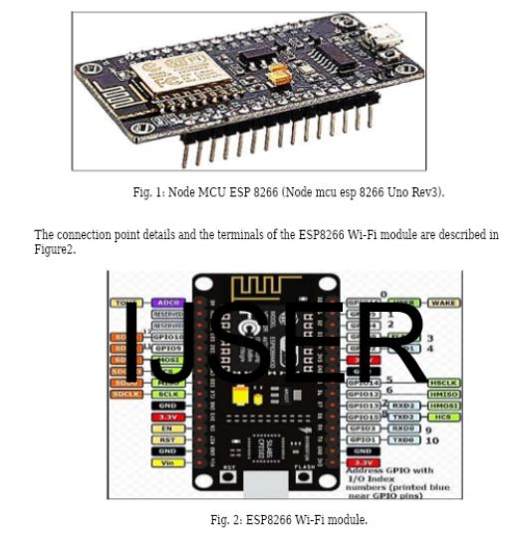

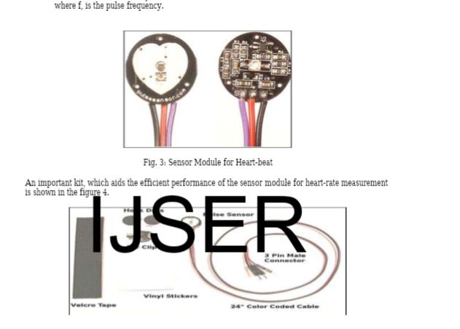

1.3 Objectives

Its primary objective is to develop an IoT-based anti-drowning device. The specific objectives are to:

i.Identify existing system weaknesses necessitating the proposed system.

ii.Design the device input-output modules using IoT Technology.

iii.Code, construct and integrate the software and the hardware using Arduino.

iv.Validate the proposed system development through testing.